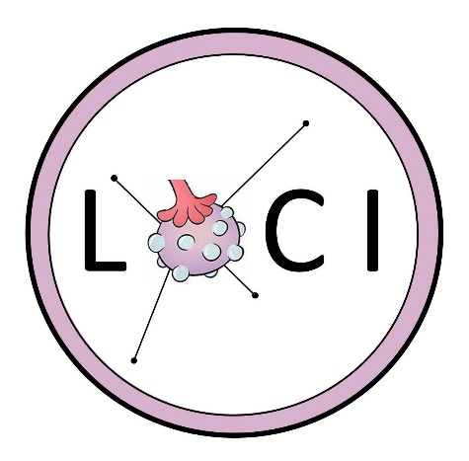

Have PCOS and trying for a baby? Join our LOCI research trial!
We are looking for women with polycystic ovary syndrome (PCOS) who are trying to conceive, to take part in a new clinical trial, called ‘LOCI’. LOCI is investigating the effectiveness of two different drugs (letrozole and clomifene) on fertility, pregnancy and successful births. Both of these drugs aim to induce or ‘switch on’ ovulation, which is often disrupted in women with PCOS. Improved ovulation should increase the chances of becoming pregnant. Clinicians and researchers do not yet know which should be the first-line medication.

Women in the study will take part in up to 6 treatment cycles where letrozole or clomifene is taken with or without (placebo) the drug metformin. These drugs are already widely used and considered safe, but the results of LOCI will provide important insights on which combination of drugs works best – something which is still unknown. By taking part in this trial you will be helping our research team move science forwards and giving many women with PCOS a better chance of getting pregnant and giving birth in future. During your involvement, you will be monitored by your clinical team and treated with respect and dignity throughout. Your data will be kept confidential at all times and you are free to leave the study at any time.

We welcome women of any ethnicity or background to take part. If language or access barriers are an issue, please let us know as we would like to facilitate your participation wherever possible e.g. providing an interpreter to help. To find out more you can check our website https://www.birmingham.ac.uk/loci and/or contact us on loci@trials.bham.ac.uk

FAQs
Q: I don’t have a formal diagnosis of PCOS, can I still take part?
In order to take part in this trial you must have a formal diagnosis of PCOS and be under the care of a fertility team. This is to ensure we are targeting the correct group of women and that you have the right clinical care in place. If you are having difficulty conceiving and think that you may have PCOS, you should see your GP for a referral to a fertility team. They should perform the necessary investigations to confirm or exclude PCOS.

Q. Are there any specific criteria to be able to take part?
Yes, in order to be able to take part in the trial you must meet the following critera:
- Formal diagnosis of PCOS and evidence of anovulation (not releasing an egg each month)
- Presentation with infertility or wishing to conceive
- Male partner (or donor sperm) with normal sperm count and motility
- Willing and able to give informed consent

Q. If I meet the requirements, are there any specific criteria which would mean I cannot take part?

The following list is our study exclusion criteria:
- If you are aged => 18 to <=42
- If your Body Mass Index (BMI) is greater than 35 kg/m²
- If you have had more than six ovulation induction treatments (cycles) with either
letrozole or clomifene in the previous 12 months - If you are wishing to continue on
metformin treatment for ovulation induction or for other indications
- If you wish for alternative methods of ovulation induction
- If you have any contraindications to letrozole, clomifene, metformin use and/or
pregnancy
- Previously participated in the LOCI trial

Q: Are the drugs letrozole, clomifene and metformin new and are they safe?
The LOCI trial has been reviewed by the West Midlands—Edgbaston Research Ethics Committee. Additionally, the study will be supervised on a regular basis by an independent Data Monitoring and Ethics Committee (DMEC) and Trial Steering Committee (TSC) to ensure the safety of all participants in the study.
The doctors and nurses/midwives caring for you will not receive any payments for recruiting women into the study. Our study participants will not be paid either, but they will be greatly appreciated, and they will be important in finding out more about how to enhance ovulation induction in women with PCOS and infertility.

All of these drugs are already widely in use, so they have been tested for safety in humans. As with any drug there may be side effects, so feel free to ask your doctor or our team about what these might be before taking part.
- Metformin is frequently used in type 2 diabetes treatment, however it is also commonly used in PCOS to regulate periods and improve fertility in women with PCOS.
- Clomifene is used to treat infertility in women who do not ovulate, including those with PCOS.
- Letrovole is used in the treatment in some kinds of breast cancer (those that respond to hormones), however it is also used to improve ovulation induction and there is evidence to suggest it may produce less side effects than clomifene.
Q: I don’t live in Birmingham, can I still take part?
This study is being conducted across the UK. We aim to have approximately 45 hospitals recruiting for this study. You can contact the trials unit to find out where your local recruiting hospital is.

Q: I take medications for other health conditions. Is this a problem or can I still take part?
This will depend on the type of medication you are on. Please get in touch with by email on loci@trials.bham.ac.uk and we can discuss your individual circumstances. If you are already taking certain medication for PCOS, such as Metformin, these would have to be stopped for 14 days weeks before you could take part in the trial.

Q: How do you decide which drug to give me or can I choose this myself?
Our research study is a randomised clinical trial, which means that we ‘randomly’ assign the drug choice to the women who are taking part in the study at the very beginning. We do this in a way that tries to ensure that each of the four experimental groups [letrozole or clomifene with or without the drug metformin, see table below] is roughly similar e.g. similar numbers of women in each group, roughly the same age range, mix of ethnicities etc. This enables us to more fairly look at the outcomes of the study and its makes the results that we get at the end more reliable.
Each volunteer will get assigned to one of the following groups:

Group 1: Letrozole and no metformin. | Group 3:Clomifene and no metformin.
Group 2: Letrozole and metformin. | Group 4:Clomifene and metformin.

Q What if there is a problem?
If you take part in the study, then you will retain the same legal rights as any other patient within the National Health Service. If you are not satisfied with any aspect of the way in which you have been approached or treated during the course of our study, then please speak first to the researchers at your hospital.
Callout advert for approval e.g. for use as a poster or on Twitter aspect ratio16:9
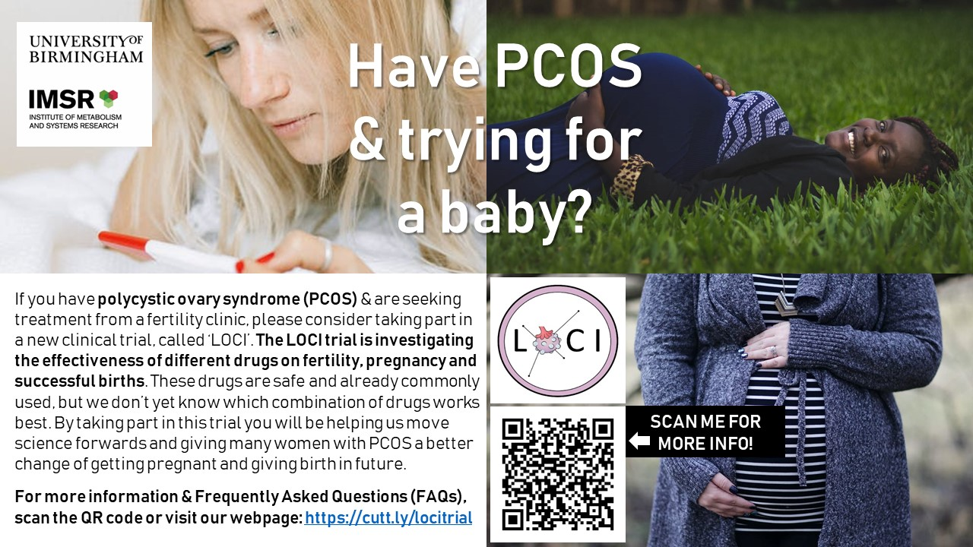

Please note: https://cutt.ly/locitrial redirects to https://www.birmingham.ac.uk/research/bctu/trials/womens/LOCItrial/index.aspx which is the webpage where I’d suggest you put the above public-facing information sheet and FAQ.

Instagram aspect ratio 1:1

